Ping Test

Test 1

$ ping 192.168.10.2 -c 10 -i 0.2
PING 192.168.10.2 (192.168.10.2) 56(84) bytes of data.
64 bytes from 192.168.10.2: icmp_seq=1 ttl=64 time=0.528 ms
64 bytes from 192.168.10.2: icmp_seq=2 ttl=64 time=0.425 ms
64 bytes from 192.168.10.2: icmp_seq=3 ttl=64 time=0.476 ms
64 bytes from 192.168.10.2: icmp_seq=4 ttl=64 time=0.480 ms
64 bytes from 192.168.10.2: icmp_seq=5 ttl=64 time=0.402 ms
64 bytes from 192.168.10.2: icmp_seq=6 ttl=64 time=0.479 ms
64 bytes from 192.168.10.2: icmp_seq=7 ttl=64 time=0.507 ms
64 bytes from 192.168.10.2: icmp_seq=8 ttl=64 time=0.501 ms
64 bytes from 192.168.10.2: icmp_seq=9 ttl=64 time=0.484 ms
64 bytes from 192.168.10.2: icmp_seq=10 ttl=64 time=0.371 ms

--- 192.168.10.2 ping statistics ---
10 packets transmitted, 10 received, 0% packet loss, time 1833ms
rtt min/avg/max/mdev = 0.371/0.465/0.528/0.047 ms

Test 2

ping 192.168.10.1 -c 10 -i 0.2
PING 192.168.10.1 (192.168.10.1) 56(84) bytes of data.
64 bytes from 192.168.10.1: icmp_seq=1 ttl=64 time=0.613 ms
64 bytes from 192.168.10.1: icmp_seq=2 ttl=64 time=0.604 ms
64 bytes from 192.168.10.1: icmp_seq=3 ttl=64 time=0.506 ms
64 bytes from 192.168.10.1: icmp_seq=4 ttl=64 time=0.410 ms
64 bytes from 192.168.10.1: icmp_seq=5 ttl=64 time=0.549 ms
64 bytes from 192.168.10.1: icmp_seq=6 ttl=64 time=0.532 ms
64 bytes from 192.168.10.1: icmp_seq=7 ttl=64 time=0.415 ms
64 bytes from 192.168.10.1: icmp_seq=8 ttl=64 time=0.567 ms
64 bytes from 192.168.10.1: icmp_seq=9 ttl=64 time=0.558 ms
64 bytes from 192.168.10.1: icmp_seq=10 ttl=64 time=0.395 ms

--- 192.168.10.1 ping statistics ---
10 packets transmitted, 10 received, 0% packet loss, time 1849ms
rtt min/avg/max/mdev = 0.395/0.514/0.613/0.076 ms

Test 3

sudo ping 192.168.10.1 -c 100 -i 0.001
PING 192.168.10.1 (192.168.10.1) 56(84) bytes of data.
64 bytes from 192.168.10.1: icmp_seq=1 ttl=64 time=0.431 ms
64 bytes from 192.168.10.1: icmp_seq=2 ttl=64 time=0.426 ms
64 bytes from 192.168.10.1: icmp_seq=3 ttl=64 time=0.383 ms
64 bytes from 192.168.10.1: icmp_seq=4 ttl=64 time=0.312 ms
64 bytes from 192.168.10.1: icmp_seq=5 ttl=64 time=0.318 ms
64 bytes from 192.168.10.1: icmp_seq=6 ttl=64 time=0.316 ms
64 bytes from 192.168.10.1: icmp_seq=7 ttl=64 time=0.353 ms
64 bytes from 192.168.10.1: icmp_seq=8 ttl=64 time=0.372 ms
64 bytes from 192.168.10.1: icmp_seq=9 ttl=64 time=0.318 ms
64 bytes from 192.168.10.1: icmp_seq=10 ttl=64 time=0.391 ms
64 bytes from 192.168.10.1: icmp_seq=11 ttl=64 time=0.293 ms
64 bytes from 192.168.10.1: icmp_seq=12 ttl=64 time=0.322 ms
64 bytes from 192.168.10.1: icmp_seq=13 ttl=64 time=0.318 ms
64 bytes from 192.168.10.1: icmp_seq=14 ttl=64 time=0.365 ms
64 bytes from 192.168.10.1: icmp_seq=15 ttl=64 time=0.363 ms
64 bytes from 192.168.10.1: icmp_seq=16 ttl=64 time=0.317 ms
64 bytes from 192.168.10.1: icmp_seq=17 ttl=64 time=0.382 ms
64 bytes from 192.168.10.1: icmp_seq=18 ttl=64 time=0.373 ms
64 bytes from 192.168.10.1: icmp_seq=19 ttl=64 time=0.384 ms
64 bytes from 192.168.10.1: icmp_seq=20 ttl=64 time=0.335 ms
64 bytes from 192.168.10.1: icmp_seq=21 ttl=64 time=0.352 ms
64 bytes from 192.168.10.1: icmp_seq=22 ttl=64 time=0.360 ms
64 bytes from 192.168.10.1: icmp_seq=23 ttl=64 time=0.357 ms
64 bytes from 192.168.10.1: icmp_seq=24 ttl=64 time=0.363 ms
64 bytes from 192.168.10.1: icmp_seq=25 ttl=64 time=0.361 ms
64 bytes from 192.168.10.1: icmp_seq=26 ttl=64 time=0.352 ms
64 bytes from 192.168.10.1: icmp_seq=27 ttl=64 time=0.357 ms
64 bytes from 192.168.10.1: icmp_seq=28 ttl=64 time=0.350 ms
64 bytes from 192.168.10.1: icmp_seq=29 ttl=64 time=0.348 ms
64 bytes from 192.168.10.1: icmp_seq=30 ttl=64 time=0.355 ms
64 bytes from 192.168.10.1: icmp_seq=31 ttl=64 time=0.345 ms
64 bytes from 192.168.10.1: icmp_seq=32 ttl=64 time=0.347 ms
64 bytes from 192.168.10.1: icmp_seq=33 ttl=64 time=0.345 ms
64 bytes from 192.168.10.1: icmp_seq=34 ttl=64 time=0.345 ms
64 bytes from 192.168.10.1: icmp_seq=35 ttl=64 time=0.347 ms
64 bytes from 192.168.10.1: icmp_seq=36 ttl=64 time=0.345 ms
64 bytes from 192.168.10.1: icmp_seq=37 ttl=64 time=0.341 ms
64 bytes from 192.168.10.1: icmp_seq=38 ttl=64 time=0.343 ms
64 bytes from 192.168.10.1: icmp_seq=39 ttl=64 time=0.342 ms
64 bytes from 192.168.10.1: icmp_seq=40 ttl=64 time=0.342 ms
64 bytes from 192.168.10.1: icmp_seq=41 ttl=64 time=0.337 ms
64 bytes from 192.168.10.1: icmp_seq=42 ttl=64 time=0.304 ms
64 bytes from 192.168.10.1: icmp_seq=43 ttl=64 time=0.301 ms
64 bytes from 192.168.10.1: icmp_seq=44 ttl=64 time=0.309 ms
64 bytes from 192.168.10.1: icmp_seq=45 ttl=64 time=0.306 ms
64 bytes from 192.168.10.1: icmp_seq=46 ttl=64 time=0.326 ms
64 bytes from 192.168.10.1: icmp_seq=47 ttl=64 time=0.343 ms
64 bytes from 192.168.10.1: icmp_seq=48 ttl=64 time=0.324 ms
64 bytes from 192.168.10.1: icmp_seq=49 ttl=64 time=0.332 ms
64 bytes from 192.168.10.1: icmp_seq=50 ttl=64 time=0.332 ms
64 bytes from 192.168.10.1: icmp_seq=51 ttl=64 time=0.336 ms
64 bytes from 192.168.10.1: icmp_seq=52 ttl=64 time=0.336 ms
64 bytes from 192.168.10.1: icmp_seq=53 ttl=64 time=0.336 ms
64 bytes from 192.168.10.1: icmp_seq=54 ttl=64 time=0.339 ms
64 bytes from 192.168.10.1: icmp_seq=55 ttl=64 time=0.337 ms
64 bytes from 192.168.10.1: icmp_seq=56 ttl=64 time=0.329 ms
64 bytes from 192.168.10.1: icmp_seq=57 ttl=64 time=0.328 ms
64 bytes from 192.168.10.1: icmp_seq=58 ttl=64 time=0.332 ms
64 bytes from 192.168.10.1: icmp_seq=59 ttl=64 time=0.330 ms
64 bytes from 192.168.10.1: icmp_seq=60 ttl=64 time=0.330 ms
64 bytes from 192.168.10.1: icmp_seq=61 ttl=64 time=0.330 ms
64 bytes from 192.168.10.1: icmp_seq=62 ttl=64 time=0.333 ms
64 bytes from 192.168.10.1: icmp_seq=63 ttl=64 time=0.328 ms
64 bytes from 192.168.10.1: icmp_seq=64 ttl=64 time=0.333 ms
64 bytes from 192.168.10.1: icmp_seq=65 ttl=64 time=0.336 ms
64 bytes from 192.168.10.1: icmp_seq=66 ttl=64 time=0.325 ms
64 bytes from 192.168.10.1: icmp_seq=67 ttl=64 time=0.341 ms
64 bytes from 192.168.10.1: icmp_seq=68 ttl=64 time=0.325 ms
64 bytes from 192.168.10.1: icmp_seq=69 ttl=64 time=0.333 ms
64 bytes from 192.168.10.1: icmp_seq=70 ttl=64 time=0.333 ms
64 bytes from 192.168.10.1: icmp_seq=71 ttl=64 time=0.329 ms
64 bytes from 192.168.10.1: icmp_seq=72 ttl=64 time=0.328 ms
64 bytes from 192.168.10.1: icmp_seq=73 ttl=64 time=0.327 ms
64 bytes from 192.168.10.1: icmp_seq=74 ttl=64 time=0.323 ms
64 bytes from 192.168.10.1: icmp_seq=75 ttl=64 time=0.321 ms
64 bytes from 192.168.10.1: icmp_seq=76 ttl=64 time=0.317 ms
64 bytes from 192.168.10.1: icmp_seq=77 ttl=64 time=0.313 ms
64 bytes from 192.168.10.1: icmp_seq=78 ttl=64 time=0.334 ms
64 bytes from 192.168.10.1: icmp_seq=79 ttl=64 time=0.315 ms
64 bytes from 192.168.10.1: icmp_seq=80 ttl=64 time=0.337 ms
64 bytes from 192.168.10.1: icmp_seq=81 ttl=64 time=0.373 ms
64 bytes from 192.168.10.1: icmp_seq=82 ttl=64 time=0.374 ms
64 bytes from 192.168.10.1: icmp_seq=83 ttl=64 time=0.377 ms
64 bytes from 192.168.10.1: icmp_seq=84 ttl=64 time=0.372 ms
64 bytes from 192.168.10.1: icmp_seq=85 ttl=64 time=0.346 ms
64 bytes from 192.168.10.1: icmp_seq=86 ttl=64 time=0.354 ms
64 bytes from 192.168.10.1: icmp_seq=87 ttl=64 time=0.333 ms
64 bytes from 192.168.10.1: icmp_seq=88 ttl=64 time=0.329 ms
64 bytes from 192.168.10.1: icmp_seq=89 ttl=64 time=0.327 ms
64 bytes from 192.168.10.1: icmp_seq=90 ttl=64 time=0.330 ms
64 bytes from 192.168.10.1: icmp_seq=91 ttl=64 time=0.335 ms
64 bytes from 192.168.10.1: icmp_seq=92 ttl=64 time=0.343 ms
64 bytes from 192.168.10.1: icmp_seq=93 ttl=64 time=0.336 ms
64 bytes from 192.168.10.1: icmp_seq=94 ttl=64 time=0.341 ms
64 bytes from 192.168.10.1: icmp_seq=95 ttl=64 time=0.336 ms
64 bytes from 192.168.10.1: icmp_seq=96 ttl=64 time=0.334 ms
64 bytes from 192.168.10.1: icmp_seq=97 ttl=64 time=0.334 ms
64 bytes from 192.168.10.1: icmp_seq=98 ttl=64 time=0.333 ms
64 bytes from 192.168.10.1: icmp_seq=99 ttl=64 time=0.333 ms
64 bytes from 192.168.10.1: icmp_seq=100 ttl=64 time=0.335 ms

--- 192.168.10.1 ping statistics ---
100 packets transmitted, 100 received, 0% packet loss, time 99ms
rtt min/avg/max/mdev = 0.293/0.340/0.431/0.022 ms

The minimum, mean and maximum results are 0.293,0.340 and 0.431 milliseconds respectively.
There are relatively minor differences between them.

Test 4

sudo ping 192.168.10.1 -c 10000 -f
PING 192.168.10.1 (192.168.10.1) 56(84) bytes of data.

--- 192.168.10.1 ping statistics ---
10000 packets transmitted, 10000 received, 0% packet loss, time 3371ms
rtt min/avg/max/mdev = 0.152/0.298/0.518/0.018 ms, ipg/ewma 0.337/0.299 ms

Test 5

CDF of Ping Test in intervals 0.01 and 1000 measures (Fig 1):

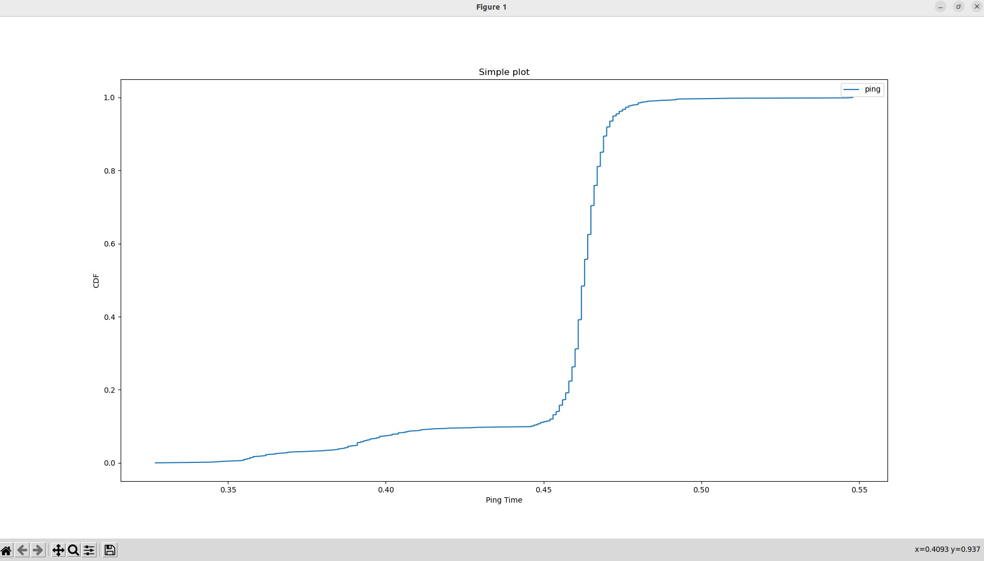
Fig 1

